CSD 330 – Security Analytics

Homework 1

Part 2

1. Find a server on the University of Houston network. Explain how you can be sure that it is on UH network. Use the helpful program called nmap to find all the open ports and services running. Make a record of the services that are running.

Answer:

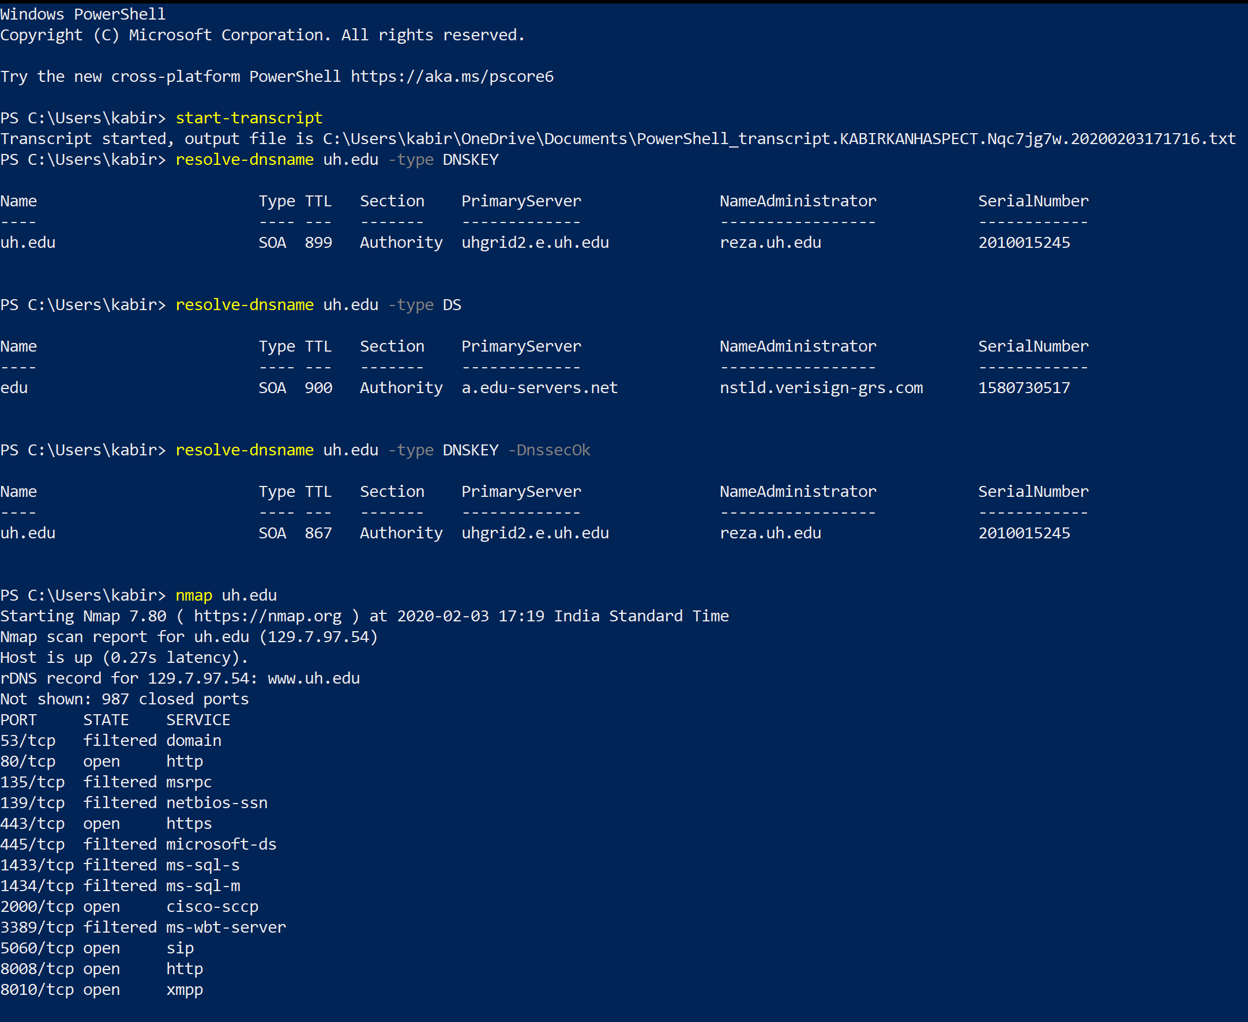

  - Verisign is a trusted certificate authority and since it has verified the server, a chain of trust is created and hence we have safely believe that this is indeed the server at University of Houston. Ports 80, 443, 2000, 5060, 8008 and 8010 are open.

2. Use NVD and CVE to find vulnerabilities in the services that are running. For this you will need the version numbers of each service on an open port. What options do you use for nmap?

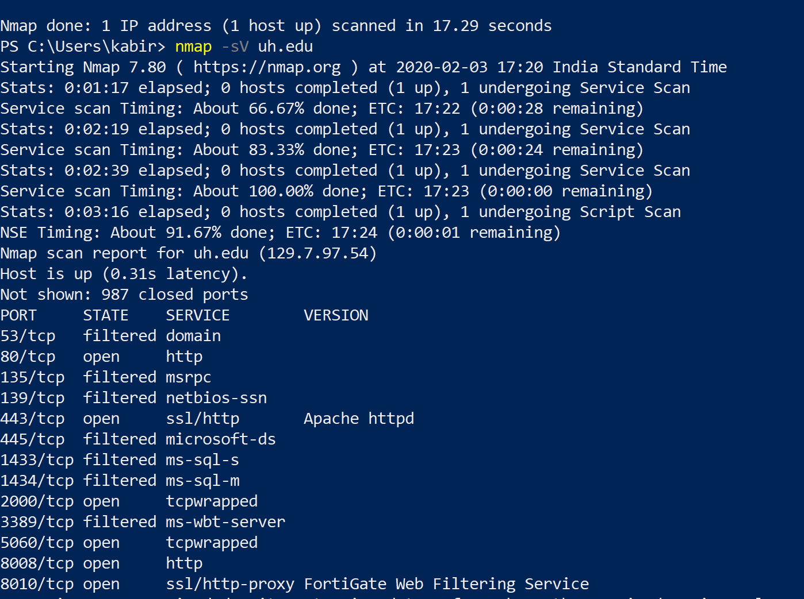

  - Here, we see that we are unable to obtain any version numbers for the running services, hence we cannot use NVD or CVE to find vulnerabilities.
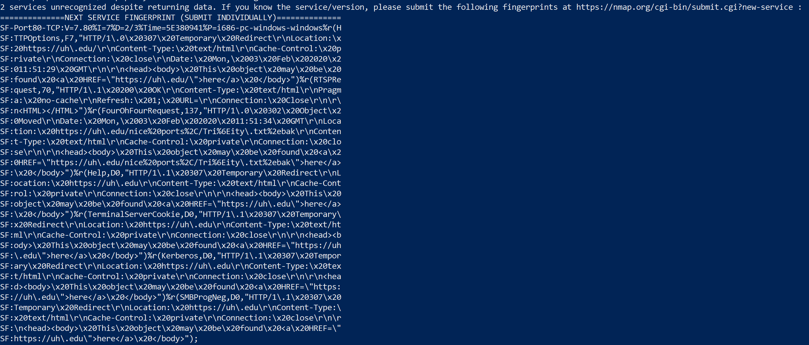
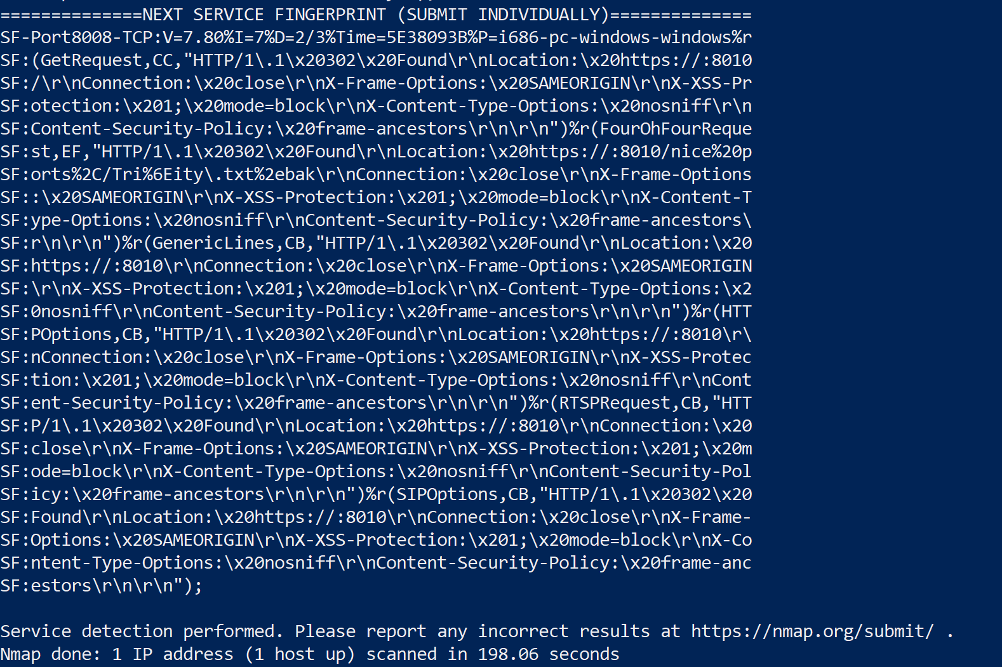

3. Check Metasploit for exploit for the vulnerability and report what Metasploit returns.
  - This question is redundant, because, as mentioned earlier, we were unable to find any vulnerabilities.

4. Next try Nmap on a small range of addresses that includes the server you found.
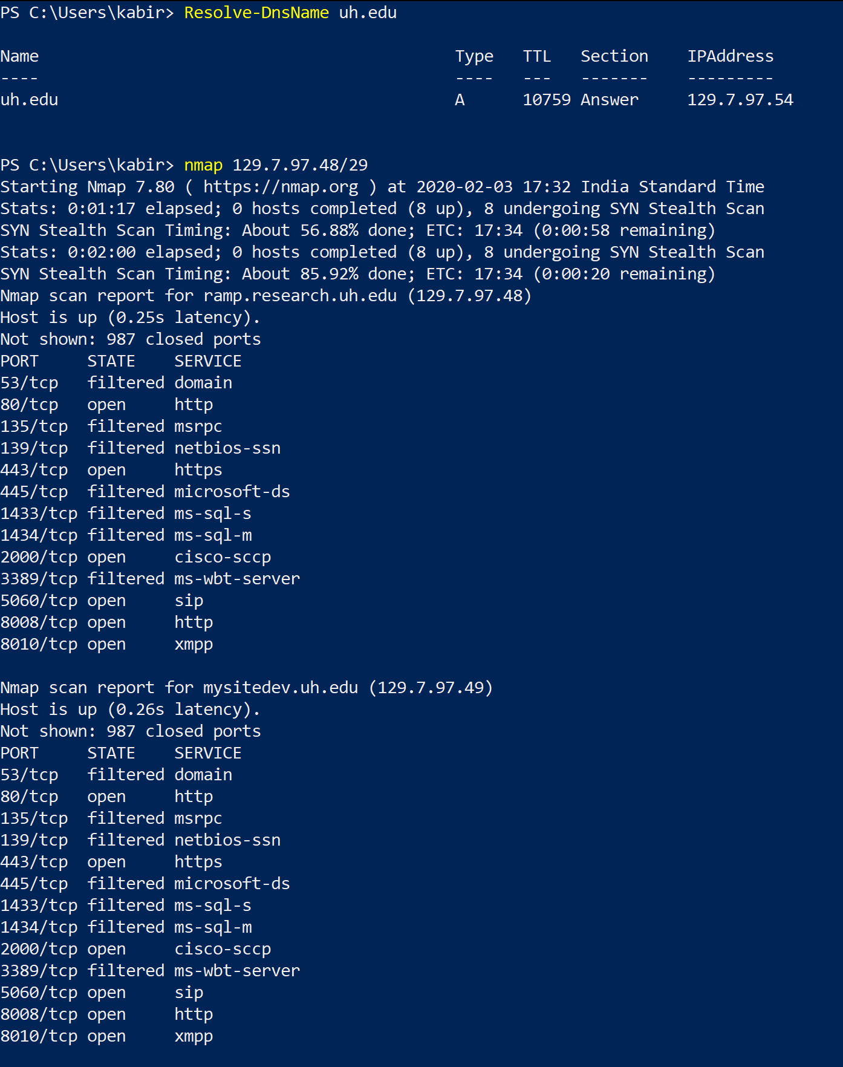
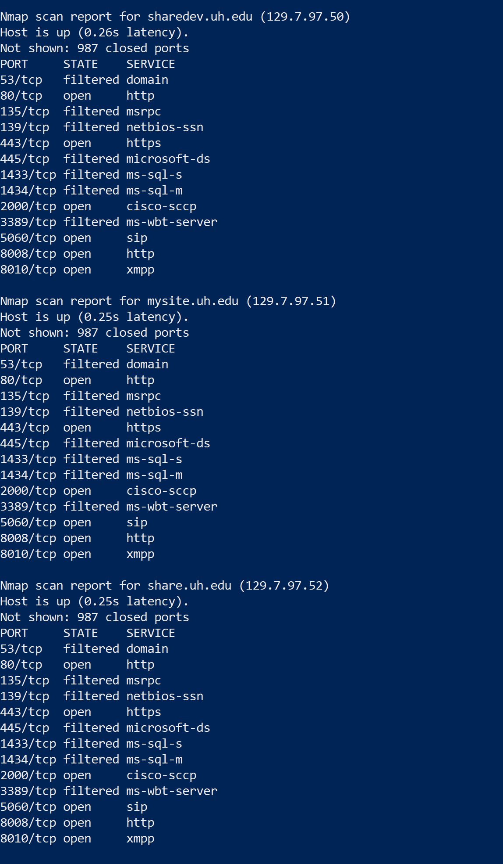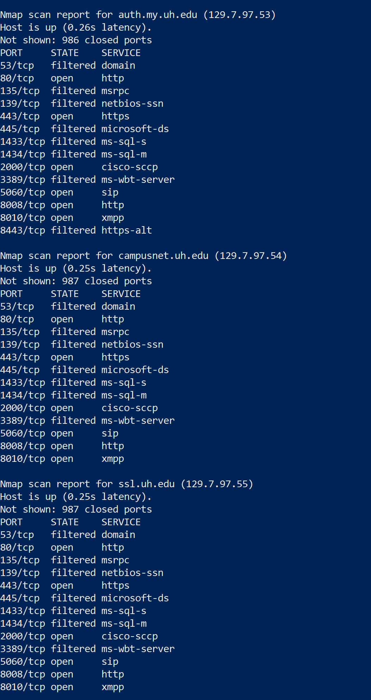

5. Using Wireshark and nmap together. The goal is to capture the nmap traffic using Wireshark
(run Nmap in ping mode) and capture all the traffic for 3 seconds. Explain how you know that you are capturing the right traffic.

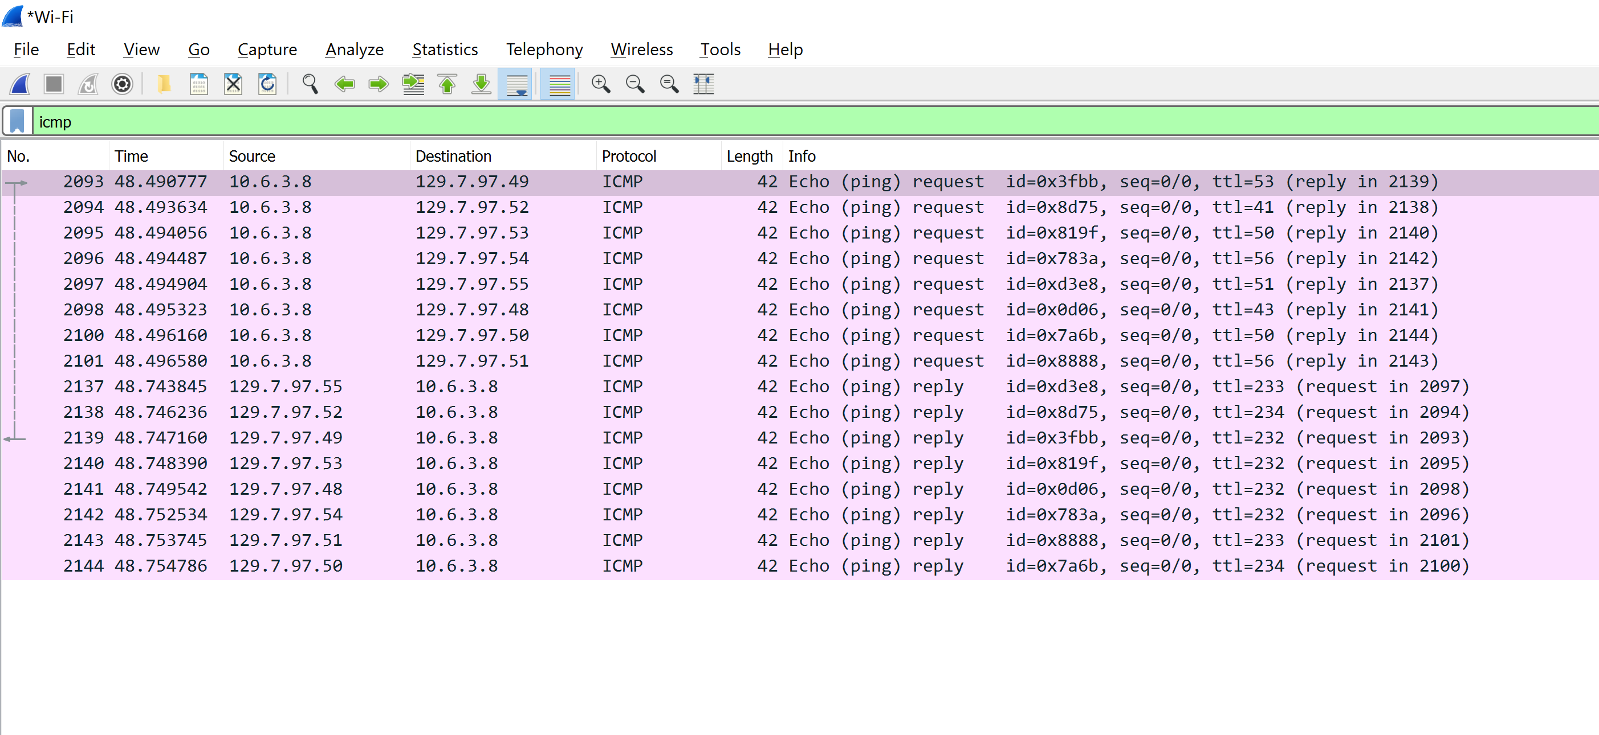

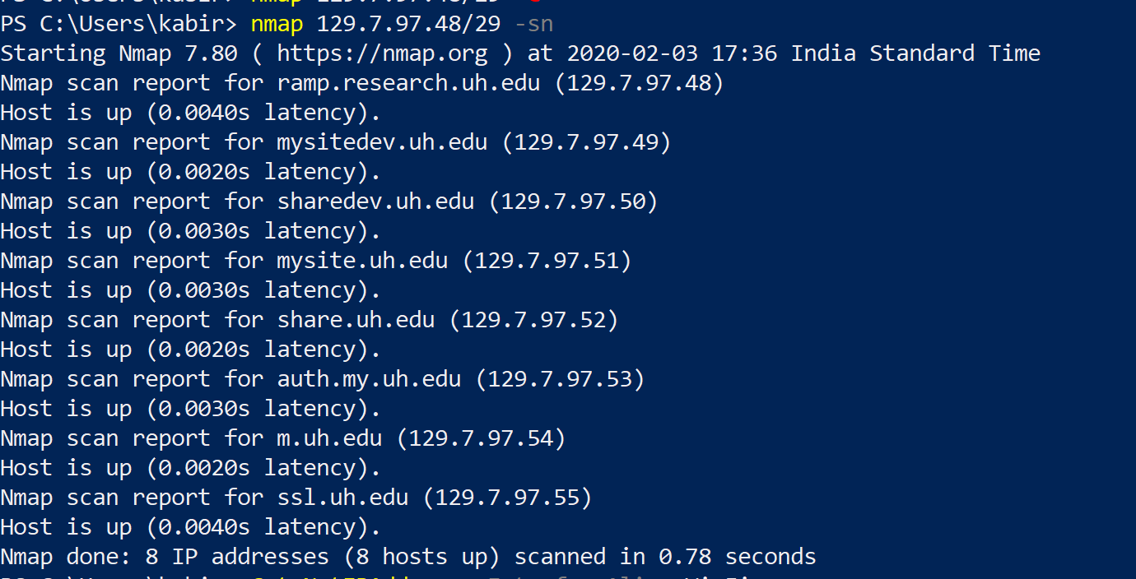

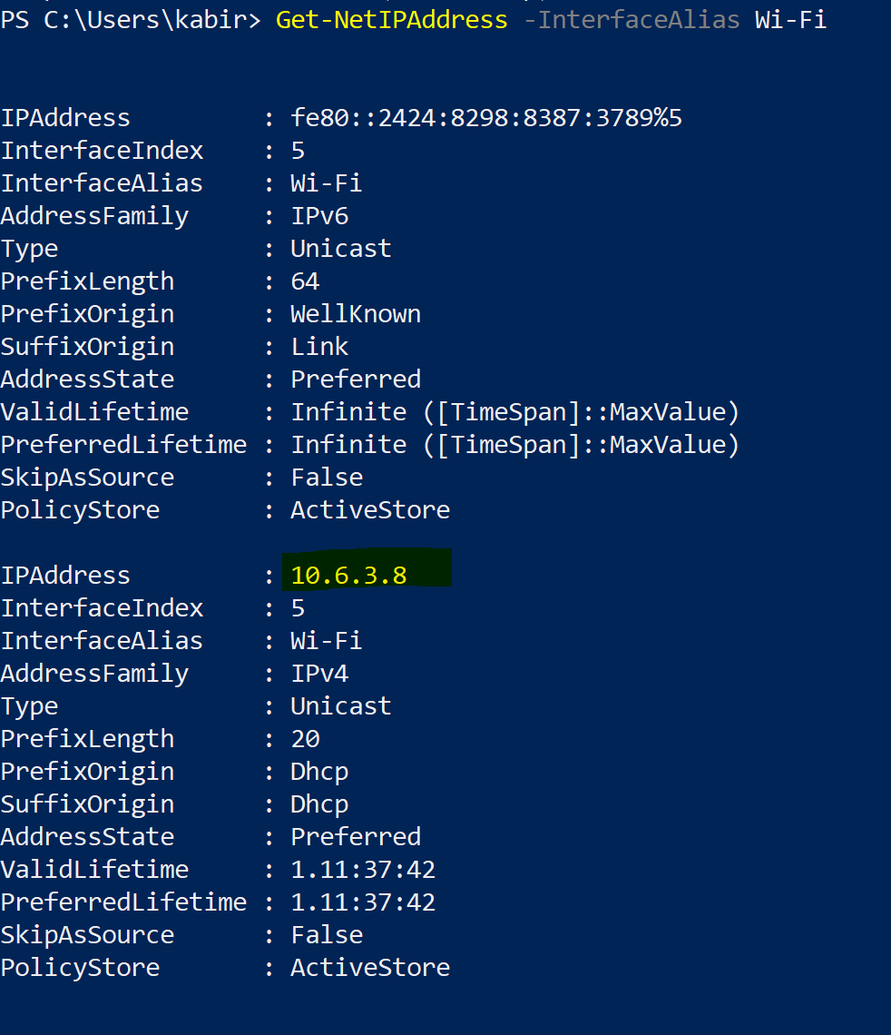

  - We see that our IP address is the same as the one from whom the ping requests are originating and replies are coming to on wireshark. Hence, verified.

6. Use a password cracking program such as John the Ripper to find all vulnerable accounts on your own devices. Report the login names and passwords it found. Run it for at least 30 minutes on each device.

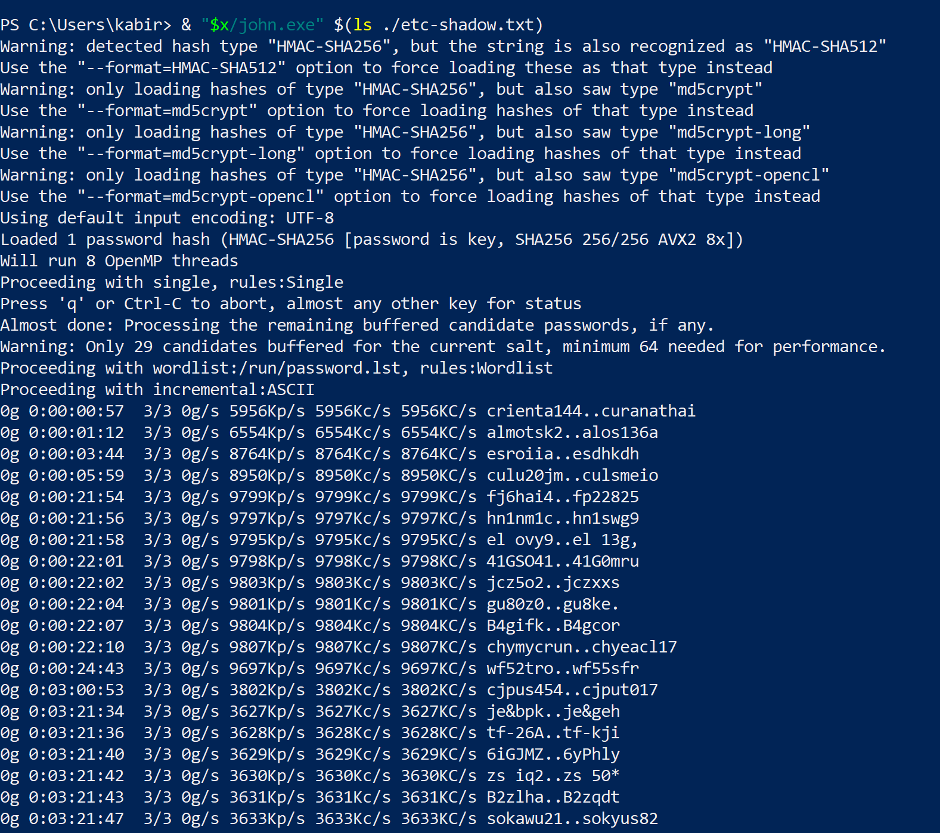

  - I ran John the Ripper on a Linux password file for 3 hours! Still no concrete result was obtained.

7. Use openssl to generate a key pair and run encryption and decryption algorithms on a short text file.

  - Please see transcript file.

